http Viewing SWIC Server

Take Note:
[For Viewing] SWIC Web Server Address: http://webdivbus.swic.edu/{User Name}
i.e. http://webdivbus.swic.edu/doej0000

Now let’s connect to the SWIC server for Viewing:
SWIC Web Server Address: http://webdivbus.swic.edu/{User Name}
i.e. http://webdivbus.swic.edu/doej0000

Enter your User Name and Password

Click on OK

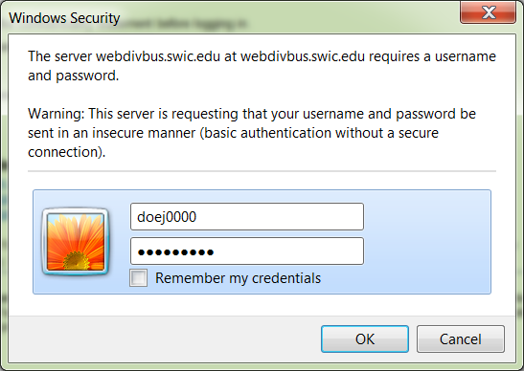

Next, a screen similar to this should appear [with the address and your name]. Note that the semesters listed may vary, but you should see and click on Fall13 ~ If this is the first time you are using the server you will only see Fall13 . [Sub Fall13 for Fall12]
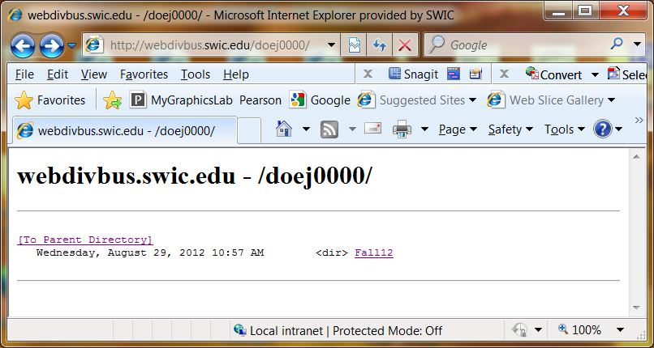 Your selection will be Fall13

Your directory will display any courses that require the Web Server. Your listing will vary but verify that your class(es) is(are) present. [Sub Fall13 for Fall12]

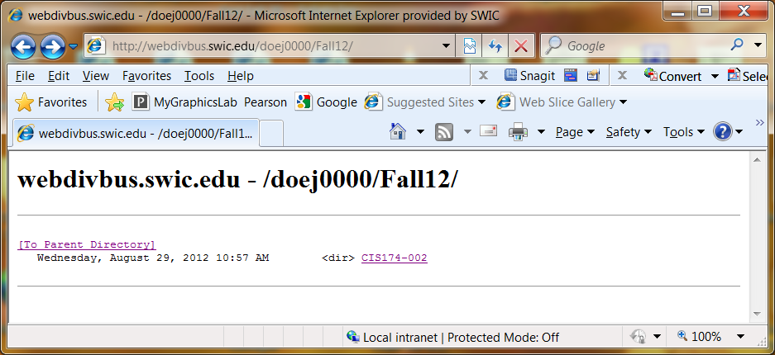

When you click on your course, for example, CIS174-002, you will find the first time that the directory is empty. [See Below] . [Sub Fall13 for Fall12]

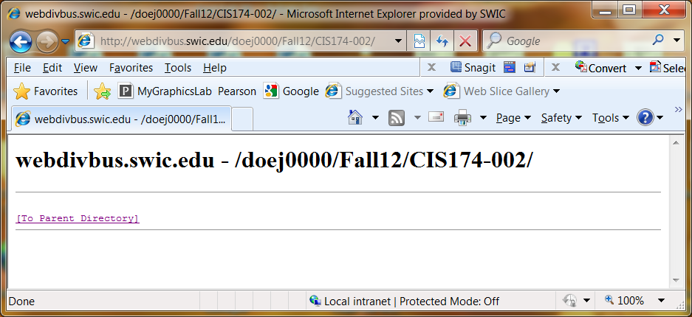

This is where you will put your web sites/folders using FileZilla ~ see Using FileZilla handout
If you do not see an expected Web site, click on the Refresh button at the top of the page.

